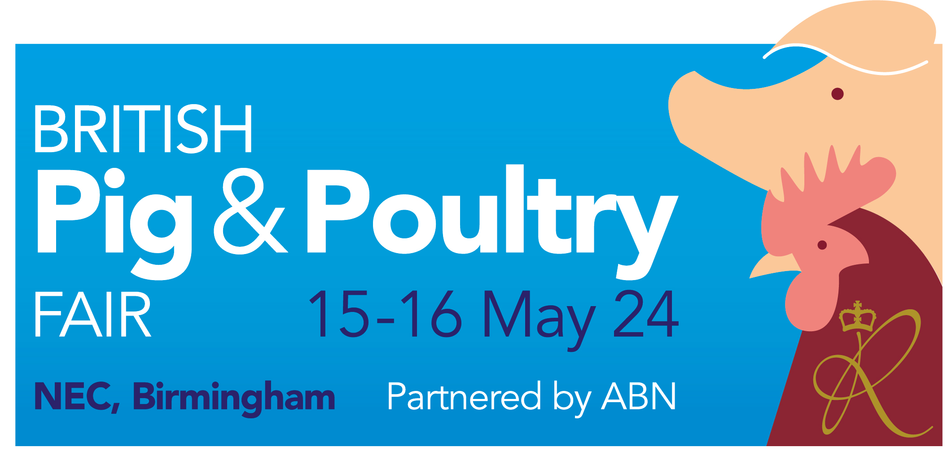
STAND FUNCTION
REQUEST FORM

If you are planning to hold a function or gathering on your stand during the Pig & Poultry Fair please complete the following Stand Function Request Form

All stand functions and organised gatherings at the Fair must be approved in advance by the organisers and may only take place between the following times:
Wednesday 15 May 08:30 and 18:00
Thursday 16 May 08:30 and 16:00

Any catering or refreshments must be organised in conjunction with the NEC catering team. For more information please refer to the exhibitor manual

Completed forms should be returned to pigpoultry@rase.org.uk by the 5 April 2024

Stand Details
Exhibiting Company Name: |  | Stand No:
Contact name:
Contact number:
Contact email:
Onsite contact name:
Onsite contact number:

Details of your stand function or gathering
Date: |  | Approx. number of guests:
Contact name on the day: |  | Start time:
Mobile Number: |  | Finish time:
Details of any food and refreshments being offered (please note this will need to be organized in conjunction with the NEC Catering team, further details can be found in the exhibitor manual):

Details of any special activity taking place eg music or live entertainment:

