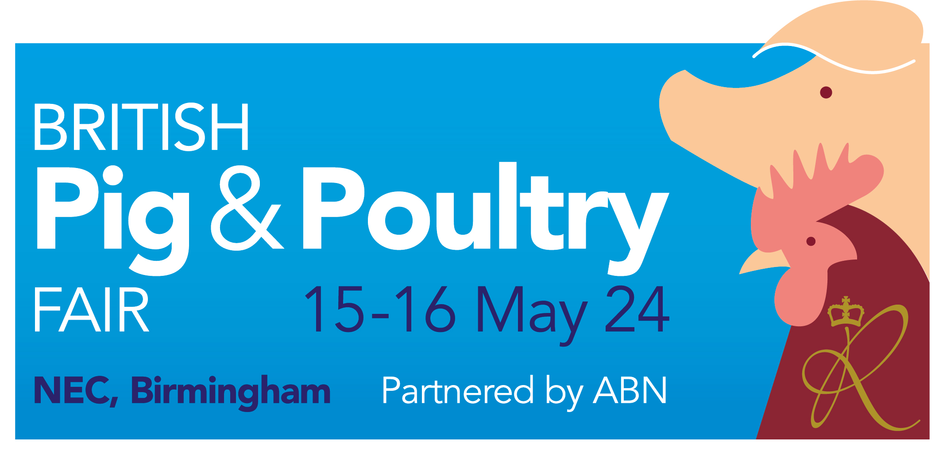
EXHIBITOR STAND RISK ASSESSMENT

Please return this form by the 5 April 2024 to: pigpoultry@rase.org.uk

Company name: |  |  |  | Stand No:
Person completing
risk assessment:
Position:
Phone:
Email:
Stand Type: | Clear Floor Space |  | Modular Unit

Activity / Hazard | Person  at Risk | Risk Evaluation Level  (low/Med/high) | Precautions & control measures in place to reduce the risk to a tolerable level

Guidance Notes

Every exhibitor must submit a risk assessment for build-up, breakdown and event days identifying the hazards present and the ways in which they will be controlled to minimise the risk.

Your risk assessment can either be submitted using the form above or alternatively you may choose to submit your assessment manually using your own pro forma.

All potential hazards should be assessed by you and included in your Risk Assessment.

- Activity/Hazard: something with the potential to cause harm (injury, loss or damage) E.g. carrying heavy items, slips/trips, source of ignition, use of electrical equipment, moving parts of machinery

- Person at Risk: E.g. member of staff, contractor, another exhibitor, visitor, cleaning/security staff

- Risk Evaluation Level: likelihood of harm being realised and the severity of the consequence if it were to occur
- High Will cause serious injury
- Medium Likely to cause medical attention
- Low Unlikely to cause injury

Precautions & Control Measures: risks should be reduced to a level which is reasonably practicable by developing and implementing control measures. E.g. Staff trained in manual handling, gangways kept clear.

